SET 29
Dataset– Student Academic Performance
Student_ID | Age | Study_Hours | Attendance (%) | Test_Score | Participation_Score
S1 | 19 | 12 | 90 | 85 | 8
S2 | 21 | 8 | 70 | 70 | 7
S3 | 20 | 15 | 95 | 92 | 9
S4 | 22 | 10 | 85 | 80 | 8
S5 | 23 | 7 | 60 | 65 | 6

1. Stacked area chart of test and participation scores
R Code

library(ggplot2)
library(tidyr)

student <- data.frame(
Student_ID = c("S1", "S2", "S3", "S4", "S5"),
Age = c(19, 21, 20, 22, 23),
Study_Hours = c(12, 8, 15, 10, 7),
Attendance = c(90, 70, 95, 85, 60),
Test_Score = c(85, 70, 92, 80, 65),
Participation_Score = c(8, 7, 9, 8, 6)
)

score_data <- pivot_longer(
student,
cols = c(Test_Score, Participation_Score),
names_to = "Score_Type",
values_to = "Score"
)

ggplot(score_data, aes(
x = Student_ID,
y = Score,
fill = Score_Type,
group = Score_Type
)) +
geom_area(position = "stack", alpha = 0.8) +
labs(
title = "Test and Participation Scores Across Students",
x = "Student ID",
y = "Stacked Score",
fill = "Score Type"
) +
theme_minimal()

Output:
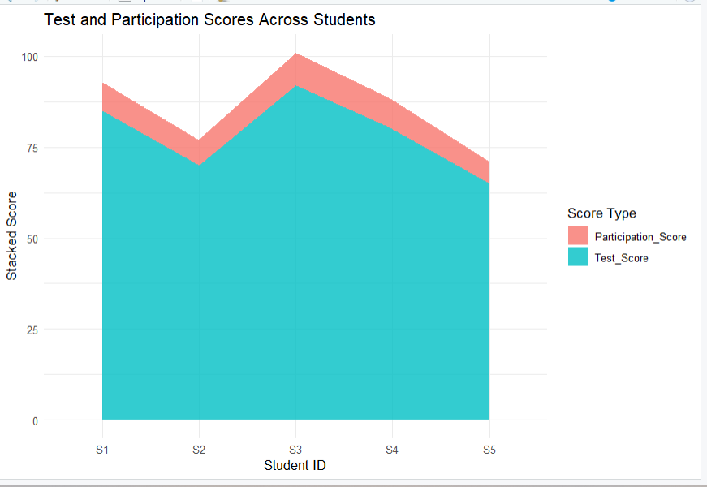
Result: S3 has the highest test score (92) and participation score (9). S5 has the lowest scores. Test scores are much larger than participation scores, so the stacked chart is dominated by test scores; the two measures use different scales.

2. Boxplot of study hours grouped by attendance quartiles
R Code

library(ggplot2)
library(dplyr)

student$Attendance_Quartile <- factor(
dplyr::ntile(student$Attendance, 4),
levels = 1:4,
labels = c("Q1 - Low", "Q2", "Q3", "Q4 - High")
)

ggplot(student, aes(
x = Attendance_Quartile,
y = Study_Hours,
fill = Attendance_Quartile
)) +
geom_boxplot() +
geom_jitter(width = 0.08, size = 2) +
labs(
title = "Study Hours by Attendance Quartile",
x = "Attendance Quartile",
y = "Study Hours"
) +
theme_minimal()

Output:
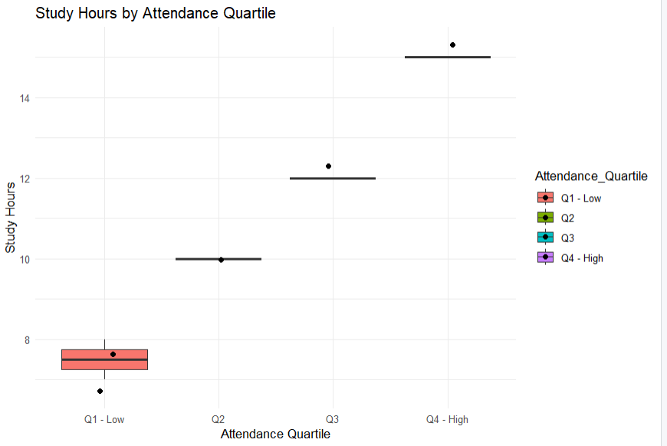
Result: The higher-attendance group contains S3, who studies 15 hours. The lowest-attendance group contains S5, who studies 7 hours. Because there are only five students, each quartile has very few observations, so medians, interquartile ranges (IQRs), and outlier detection are limited. The plot does not provide enough data to establish a reliable relationship.

3. Density plot of test scores
R Code

ggplot(student, aes(x = Test_Score)) +
geom_density(
fill = "skyblue",
color = "blue",
alpha = 0.6,
adjust = 1
) +
labs(
title = "Distribution of Student Test Scores",
x = "Test Score",
y = "Density"
) +
theme_minimal()

Output:
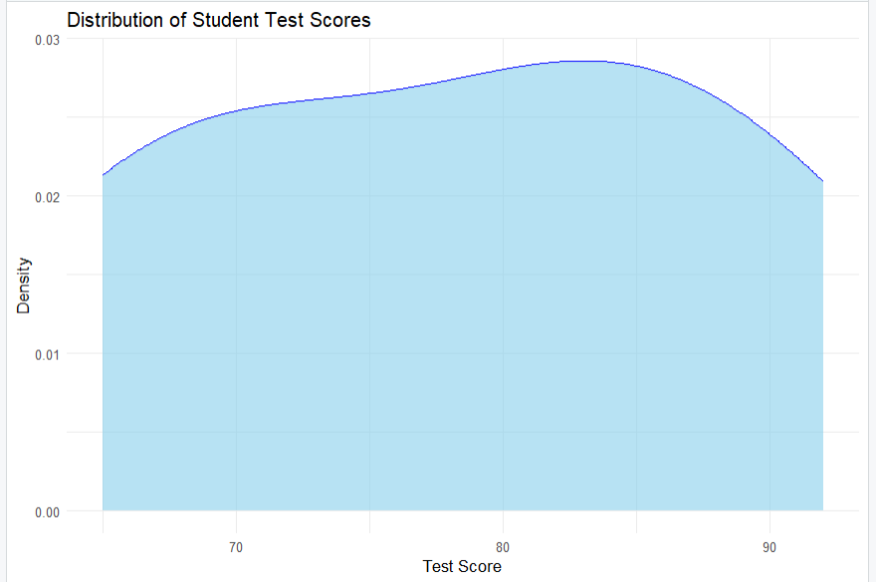
Result: Test scores range from 65 to 92, with S3 having the highest score and S5 the lowest. A density curve based on only five scores is a rough illustration and cannot reliably identify the population distribution or outliers.

4. Interactive Tableau scatterplot
Procedure (Tableau)
- Import the student dataset into Tableau.
- Drag Study_Hours to Columns and Test_Score to Rows.
- Drag Student_ID to Detail so each student appears as a separate point.
- Drag Participation_Score to Color and select a color gradient.
- Drag Age to Filters, select Show Filter, and choose the age values to explore.
- Add Student_ID, Age, Study_Hours, Attendance, Test_Score, and Participation_Score to Tooltip.
- Place the scatterplot and age filter on a dashboard titled Student Academic Performance Dashboard.

Output:
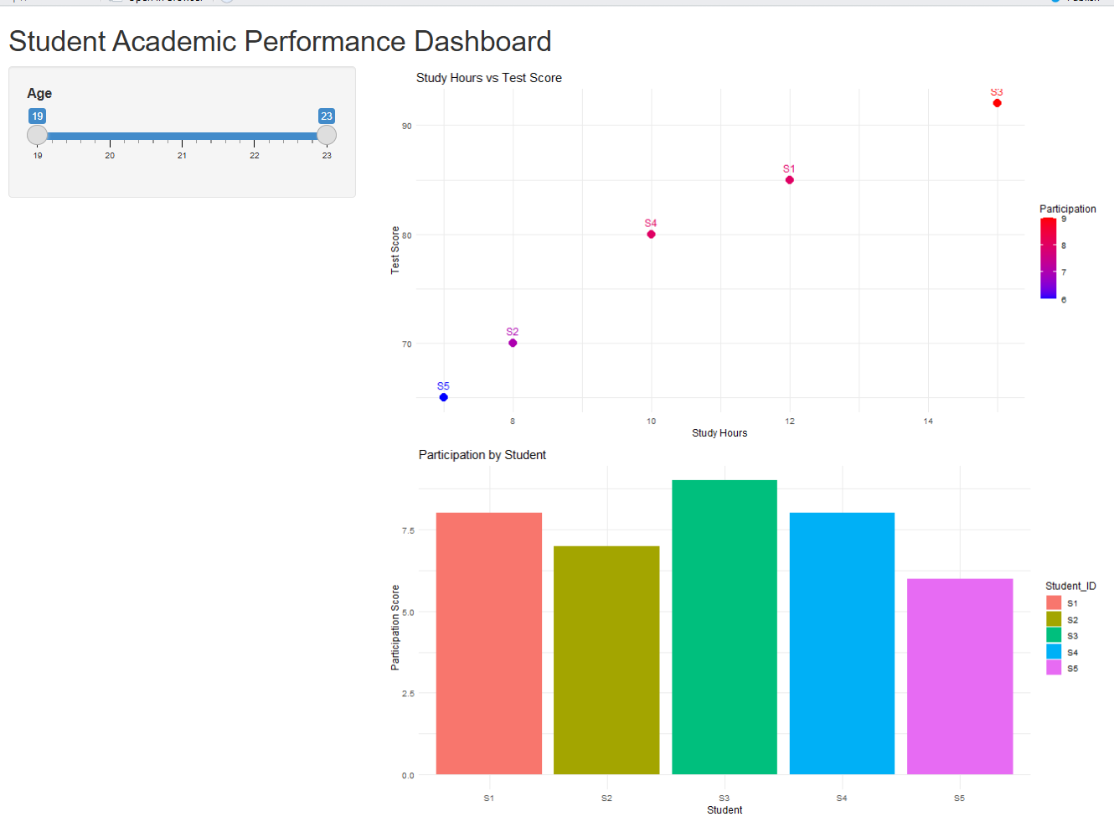
Result: S3 studies the most (15 hours) and has the highest test score (92). S5 studies the least (7 hours) and has the lowest test score (65). The dashboard helps compare study time, test performance, participation, and age. The pattern is suggestive, but the small dataset cannot establish causation.

